**Racing Game Setup**

1. Open up the visual studio solution file named Racing.sln.
2. Build the solution selecting Build Solution from the Visual Studio Build menu.
3. Once the build is successful you can setup the database. Open up the Package Manager Console by clicking on the tab at the bottom of Visual Studio. Type in the command as shown in the image below. This will create a Database named Racing on your local instance of SQL Server.

If you want to change the database information you can do so by opening up the RacingContext.cs file. Change the connection in the below method.

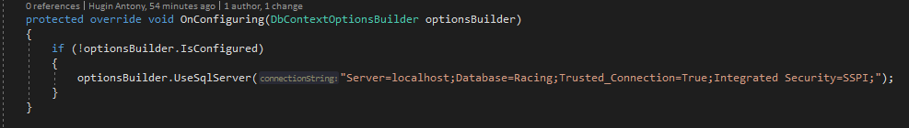

Alternatively, you can run the SQL script found in the Scripts folder of the project. Copy the contents of the schema.sql file into your database IDE and run it.

1. You are now ready to play the game. Click on the start button in Visual Studio. As shown in the image below

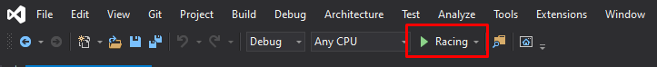

1. When the game start you will be shown this:

1. Enter in a track id that you want. After entering a valid track id, you will car information for all cars in the game. Press any key to play.

1. After the game starts, you will see the results of the race. You then then press any key to play again or press Q to quit the game.

